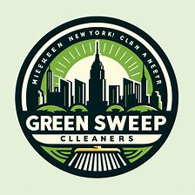

Green Sweep Cleaners

**Executive Summary**

* **Business Name**: Green Sweep Cleaners
* **Location**: New York City
* **Specialization**: Cleaning offices and commercial premises using eco-friendly materials.
* **Objective**: To provide high-quality, environmentally responsible cleaning services to local businesses.

**Market Overview**

* **Target Market**: Offices and commercial spaces in NYC seeking sustainable cleaning options.
* **Competition**: Traditional cleaning companies not focused on eco-friendly practices.
* **Opportunity**: Growing demand for green services in urban areas.

**Financial Projections**

* **Startup Costs**: Estimated at $10,000 for equipment, materials, and marketing.
* **Revenue Streams**: Service fees from cleaning contracts.
* **Profit Margins**: Expected to increase as the business scales and operational efficiency improves.

This plan is based on the initial information provided and would be further developed with more detailed research and analysis.